**REPORT ON SUBNETTING CALCULATION**

**NAME: MUIRURI DENNIS BANGA**

**REG NO: P15/1475/2012**

**DEPT: COMPUTER SCIENCE**

**COURSE: CSC226 COMPUTER SYSTEMS AND NETWORKING LAB**

**DATE OF SUBMISSION: 27/3/2014**

**REPORT ON SUBNETTING CALCULATIONS**

1. **192.16.8.1.0/29 Class C**

Number of Host bits=3

Number of Network bits=5

Number of Hosts: 2^3-2=**6 hosts/subnet**

(Minus 2 is for the network id and broadcast id).

Number of Subnets: 2^5-2=**30 subnets**

Mask=248

Block size =256-Mask

Block size: 256-248=8

Subnet Mask: 255.255.255.248

Table of the Hosts and Subnets:

|  |  |  |  |  |  |
| --- | --- | --- | --- | --- | --- |
| SUBNET ID | 192.168.1.0 | 192.168.1.8 | 192.168.1.16 | 192.168.1.240 | 192.168.1.248 |
| FIRST HOST ID | 192.168.1.1 | 192.168.1.9 | 192.168.1.17 | 192.168.1.241 | 192.168.1.249 |
| LAST HOST ID | 192.168.1.6 | 192.168.1.14 | 192.168.1.22 | 192.168.1.246 | 192.168.1.254 |
| BROADCAST ID | 192.168.1.7 | 192.168.1.15 | 192.168.1.23 | 192.168.1.247 | 192.168.1.255 |

1. **192.16.8.1.0/27 Class C**

Number of Host bits=5

Number of Network bits=3

Number of Hosts: 2^5-2=**30 hosts/subnet**

(Minus 2 is for the network id and broadcast id).

Number of Subnets: 2^3-2=**6 subnets**

Block size: 256-224=32

Subnet Mask: 255.255.255.224

Table of the Hosts and Subnets:

|  |  |  |  |  |  |
| --- | --- | --- | --- | --- | --- |
| SUBNET IDS | 192.168.1.0 | 192.168.1.32 | 192.168.1.64 | 192.168.1.192 | 192.168.1.224 |
| FIRST HOST ID | 192.168.1.1 | 192.168.1.33 | 192.168.1.65 | 192.168.1.193 | 192.168.1.225 |
| LAST HOST ID | 192.168.1.30 | 192.168.1.62 | 192.168.1.94 | 192.168.1.222 | 192.168.1.254 |
| BROADCAST ID | 192.168.1.31 | 192.168.1.63 | 192.168.1.95 | 192.168.1.223 | 192.168.1.255 |

1. **192.16.8.1.0/30 Class C**

Number of Host bits=2

Number of Network bits=6

Number of Hosts: 2^2-2=**2 hosts/subnet**

(Minus 2 is for the network id and broadcast id).

Number of Subnets: 2^6-2=**62 subnets**

Block size: 256-252=4

Subnet Mask: 255.255.255.252

Table of the Hosts and Subnets:

|  |  |  |  |  |  |
| --- | --- | --- | --- | --- | --- |
| SUBNET IDS | 192.168.1.0 | 192.168.1.4 | 192.168.1.8 | 192.168.1.248 | 192.168.1.252 |
| FIRST HOST ID | 192.168.1.1 | 192.168.1.5 | 192.168.1.9 | 192.168.1.249 | 192.168.1.253 |
| LAST HOST ID | 192.168.1.2 | 192.168.1.6 | 192.168.1.10 | 192.168.1.250 | 192.168.1.254 |
| BROADCAST ID | 192.168.1.3 | 192.168.1.7 | 192.168.1.11 | 192.168.1.251 | 192.168.1.255 |

1. **192.16.8.1.0/25 class C**

Number of Host bits=7

Number of Network bits=1

Number of Hosts: 2^7-2=**128 hosts/subnet**

(Minus 2 is for the network id and broadcast id).

Number of Subnets: 2^1-2=**0 subnets**

Block size: 256-128=128

Not possible, Getting 0 subnets.

1. **172.16.0.0/23 class B**

Number of Host bits=9

Number of Network bits=7

Number of Hosts: 2^9-2=**510 hosts/subnet**

(Minus 2 is for the network id and broadcast id).

Number of Subnets: 2^7-2=**126 subnets**

Block size: 256-254=2

Subnet Mask: 255.255.254.0

Table of the Hosts and Subnets:

|  |  |  |  |  |  |
| --- | --- | --- | --- | --- | --- |
| SUBNET IDS | 172.16.0.0 | 172.16.2.0 | 192.168.4.0 | 172.16.252.0 | 172.16.254.0 |
| FIRST HOST ID | 172.16.0.1 | 192.16.2.1 | 172.16.4.1 | 172.16.252.1 | 172.16.254.1 |
| LAST HOST ID | 172.16.1.254 | 192.16.3.254 | 172.16.5.254 | 172.16.253.254 | 172.16.255.254 |
| BROADCAST ID | 172.16.1.255 | 192.16.3.255 | 172.16.5.255 | 172.16.253.255 | 172.16.255.255 |

1. **172.16.0.0/21 Class B**

Number of Host bits=11

Number of Network bits=5

Number of Hosts: 2^11-2=**2046 hosts/subnet**

(Minus 2 is for the network id and broadcast id).

Number of Subnets: 2^5-2=**30 subnets**

Block size: 256-248=8

Subnet Mask: 255.255.248.0

Table of the Hosts and Subnets:

|  |  |  |  |  |  |
| --- | --- | --- | --- | --- | --- |
| SUBNETS IDS | 172.16.0.0 | 172.16.8.0 | 172.16.16.0 | 172.16.240.0 | 172.16.248.0 |
| FIRST HOST ID | 172.16.0.1 | 192.16.8.1 | 172.16.16.1 | 172.16.240.1 | 172.16.248.1 |
| LAST HOST ID | 172.16.7.254 | 192.16.15.254 | 172.16.23.254 | 172.16.247.254 | 172.16.255.254 |
| BROADCAST ID | 172.16.7.255 | 192.16.15.255 | 172.16.23.255 | 172.16.247.255 | 172.16.255.255 |

1. **172.16.0.0/19 class B**

Number of Host bits=13

Number of Network bits=3

Number of Hosts: 2^13-2=**8190 hosts/subnet**

(Minus 2 is for the network id and broadcast id).

Number of Subnets: 2^3-2=**6 subnets**

Block size: 256-224=32

Subnet Mask: 255.255.224.0

Table of the Hosts and Subnets:

|  |  |  |  |  |  |
| --- | --- | --- | --- | --- | --- |
| SUBNETS IDS | 172.16.0.0 | 172.16.32.0 | 172.16.64.0 | 172.16.192.0 | 172.16.224.0 |
| FIRST HOST ID | 172.16.0.1 | 192.16.32.1 | 172.16.64.1 | 172.16.192.1 | 172.16.224.1 |
| LAST HOST ID | 172.16.31.254 | 192.16.63.254 | 172.16.95.254 | 172.16.223.254 | 172.16.255.254 |
| BROADCAST ID | 172.16.31.255 | 192.16.63.255 | 172.16.95.255 | 172.16.224.255 | 172.16.255.255 |

1. **172.16.0.0/17 Class B**

Number of Host bits=15

Number of Network bits=1

Number of Hosts: 2^13-2=**32766 hosts/subnet**

(Minus 2 is for the network id and broadcast id).

Number of Subnets: 2^1-2=**0 subnets**

Block size: 256-128=128

It has 0 subnets, it is not possible to subnet.

1. **10.0.0.0/14 Class A**

Number of Host bits=18

Number of Network bits=6

Number of Hosts: 2^18-2=**262142 hosts/subnet**

(Minus 2 is for the network id and broadcast id).

Number of Subnets: 2^6-2=**62 subnets**

Block size: 256-252=4

Subnet Mask: 255.252.0.0

Table of the Hosts and Subnets:

|  |  |  |  |  |  |
| --- | --- | --- | --- | --- | --- |
| SUBNETS IDS | 10.0.0.0 | 10.4.0.0 | 10.8.0.0 | 10.248.0.0 | 10.252.0.0 |
| FIRST HOST ID | 10.0.0.1 | 10.4.0.1 | 10.8.0.1 | 10.248.0.1 | 10.252.0.1 |
| LAST HOST ID | 10.3.255.254 | 10.7.255.254 | 10.11.255.254 | 10.251.255.254 | 10.255.255.254 |
| BROADCAST ID | 10.3.255.255 | 10.7.255.255 | 10.11.255.255 | 10.251.255.255 | 10.255.255.255 |

1. **10.0.0.0/13 Class A**

Number of Host bits=19

Number of Network bits=5

Number of Hosts: 2^18-2=**524286 hosts/subnet**

(Minus 2 is for the network id and broadcast id).

Number of Subnets: 2^5-2=**30 subnets**

Block size: 256-248=8

Subnet Mask: 255.248.0.0

Table of the Hosts and Subnets:

|  |  |  |  |  |  |
| --- | --- | --- | --- | --- | --- |
| SUBNET IDS | 10.0.0.0 | 10.8.0.0 | 10.16.0.0 | 10.240.0.0 | 10.248.0.0 |
| FIRST HOST ID | 10.0.0.1 | 10.8.0.1 | 10.16.0.1 | 10.240.0.1 | 10.248.0.1 |
| LAST HOST ID | 10.7.255.254 | 10.15.255.254 | 10.23.255.254 | 10.247.255.254 | 10.255.255.254 |
| BROADCAST ID | 10.7.255.255 | 10.15.255.255 | 10.23.255.255 | 10.247.255.255 | 10.255.255.255 |

Cisco Packet Tracer-Creating a network of three computers using class C.

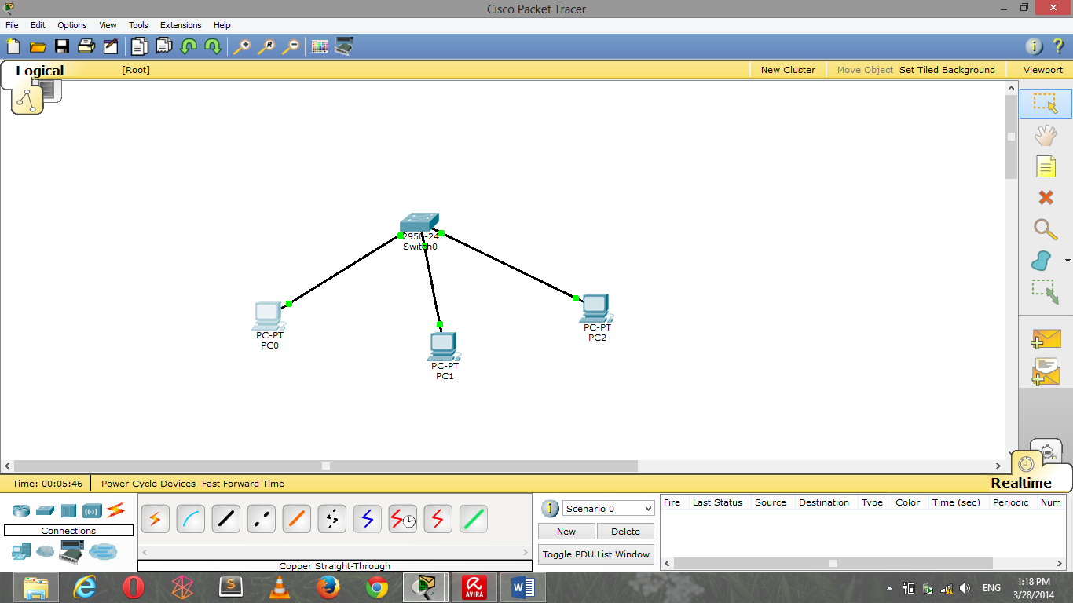

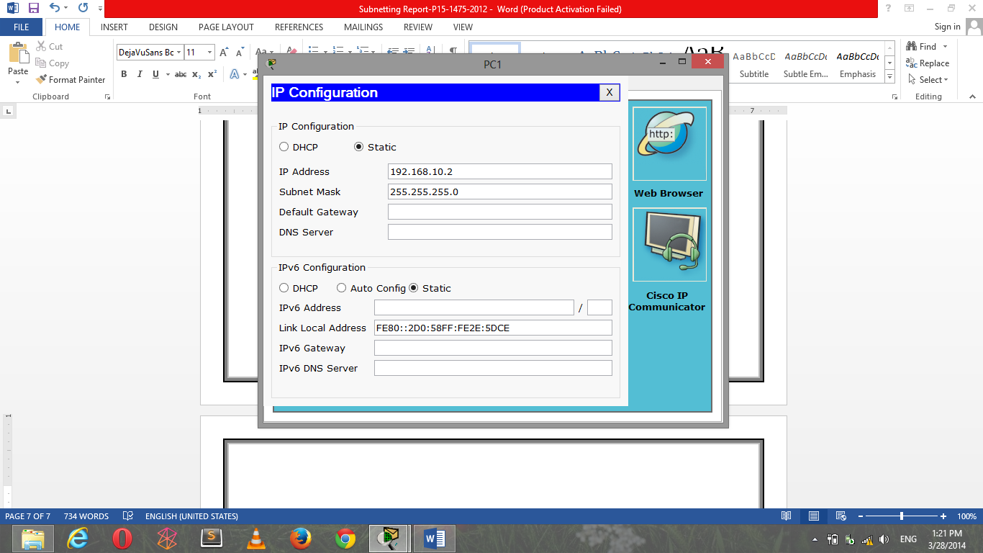

Assigning IPs to the Machines.

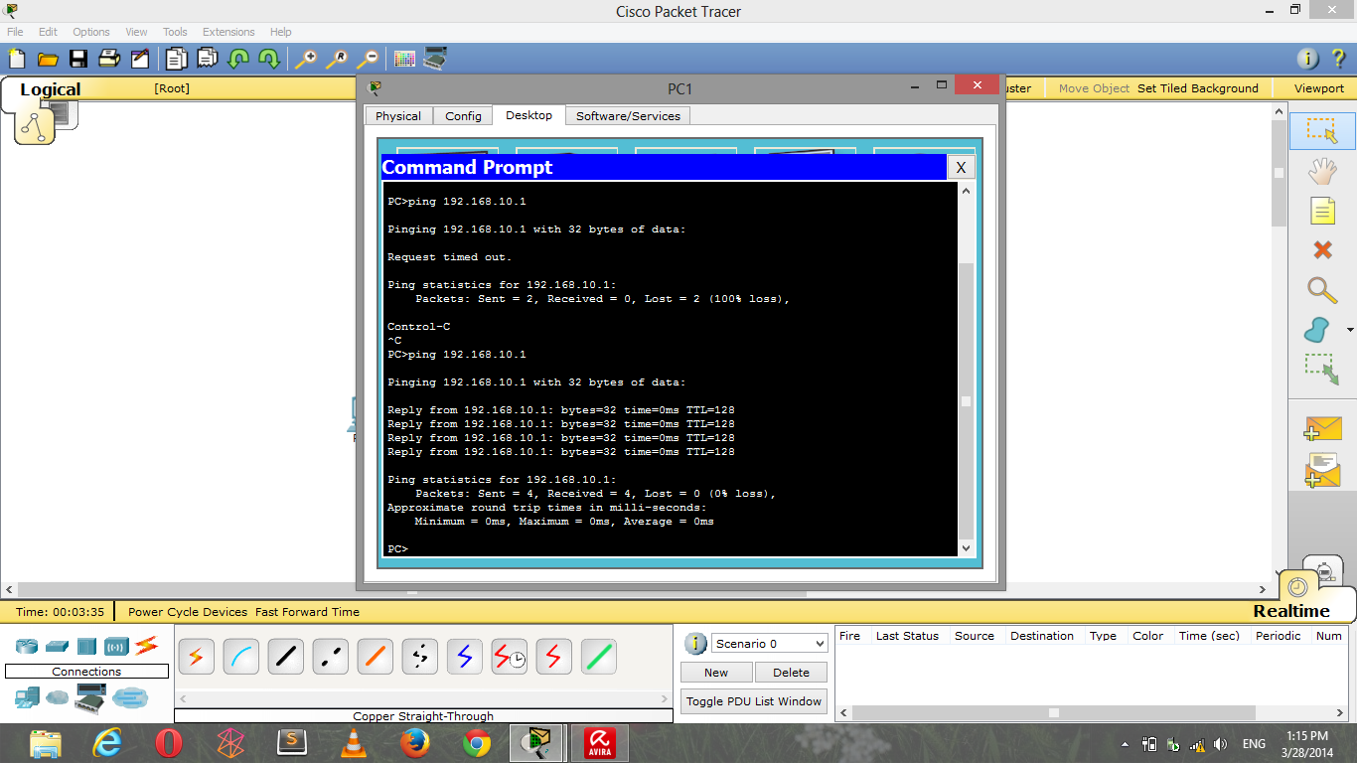

Pinging the Machines to check whether they can be found and can communicate.